**Name:** Nnadiekwe Chiderah David

*Automating Apache web server deployment using EC2 UserData*

1. Create an EC2 instance on AWS with a user-data script that automates the installation and configuration of an HTTP server.

1. In the user-data script, install the HTTP server of your choice (such as Apache) and configure it to start automatically on boot.

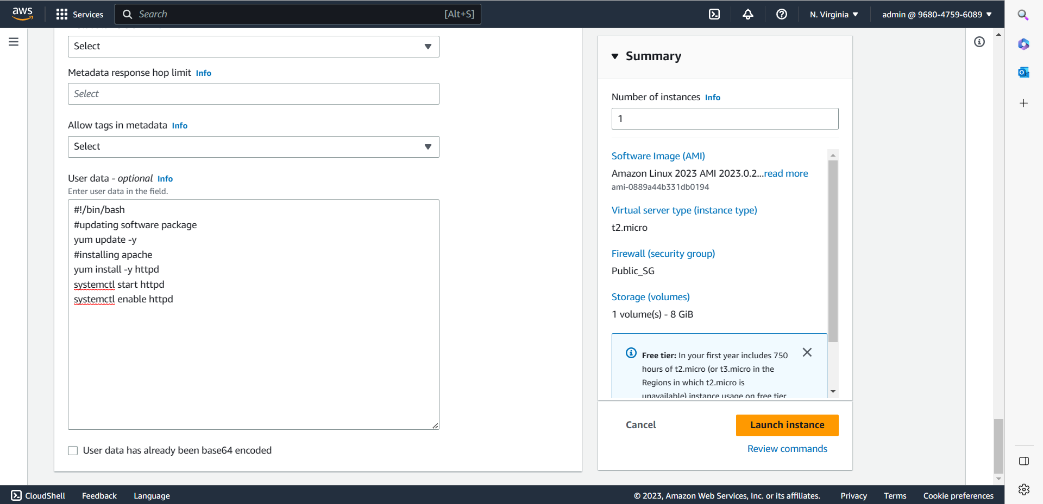

1. Create an HTML file and host it on the HTTP server.

1. Verify that you can access the HTML file by browsing to the public IP address of the instance in a web browser.

